 | 18.1.1 Editors - Graph Editor - Header tools and options
Table of content
Introduction 3
Header Tabs 3
Use Normalization, Create Ghost Curves 3
Use Normalization 3
Create Ghost Curves 3
Snapping Panel 3
Toggle Snapping On/Off 3
Frame 4
Second 4
Nearest Market 4
Absolute Time Snap 4
Show Hide elements 4
Only Show Selected 4
Show Hidden 4
Only Show Errors 4
Filters 4
Filter by Collection 4
Filter by Type 5
Options 5
Sort Data Blocks 5
Proportional Editing 5
Enable proportional editing 5
Proportional Editing Falloff 5
Falloff Type 5
Proportional Size 5
Pivot Point 5
Bounding Box Center 5
2D Cursor 5
Individual Centers 5
Easing Mode 6
Easing Mode 6
Last Operator Set Keyframe Easing Type 6
Type 6
Keyframe Handle Type 6
Last Operator Set Keyframe Handle Type 6
Type 6
Keyframe Interpolation 6
Last Operator Set Keyframe Interpolation 7
Type 7
Options 7
Real-time Updates 7
Show Seconds 7
Sync visible range 7
Show Sliders 7
AutoMerge Keyframes 7
Auto Lock Key Axis 7
Show Extrapolation 7
Show Handles 8
Only Selected Keyframes Handles 8
Show Markers 8
Lock Markers 8

Introduction

The header contains various menus and tools. This chapter here is about the tools, modes and options elements in the header.

The text menus are covered in a own chapter each. They vary too much, dependent of mode and object type.

Header Tabs

The tabs at the very left allows you to switch between the four most important editor types by one click. Dope sheet Editor, Graph Editor, Driver Editor, NLA Editor.

Use Normalization, Create Ghost Curves

Use Normalization
Normalizes the curves so that the maximum does not exceed 1 and the minimum does not go lower than -1

Create Ghost Curves
Creates a snapshot of the current curves, and displays it as a background image in the viewport. This background image is not permanent, and will be deleted when you close Bforartists.
When a ghost background image is created then the button turns into a delete button with which you can remove the ghost image.

Snapping Panel
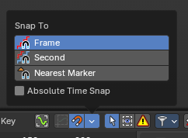
Snapping in animation editors helps align the playhead and keyframes to meaningful time-based elements, improving precision and workflow efficiency across the Timeline, Dope Sheet, Graph Editor, NLA, and Video Sequencer.
Note: This sub-subpanel is not available for Grease Pencil Dopesheet Mode

Toggle Snapping On/Off
Toggles the snapping on or off with a visual indicator.

Frame
Snaps to whole frame numbers. Ideal for frame-accurate editing instead of sub-frame timeline cursor placement.

Second
Snaps to time intervals measured in seconds. Useful for audio syncing or time-based pacing.

Nearest Market
Snaps to the closest timeline marker. Great for aligning actions to scene events or beats.

Absolute Time Snap
When enabled, snapping uses absolute time rather than relative pixel proximity. Ensures consistent snapping behavior regardless of zoom level or cursor position.

Show Hide elements

Only Show Selected
Display only the data for the selected object in the list of elements. If off it displays all available animation data of the whole scene.

Show Hidden
Include channels from objects / bones that are not visible. This feature just works with Only Selected off.

Only Show Errors
Only display F-Curves and Drivers that have errors or are disabled.

Filters
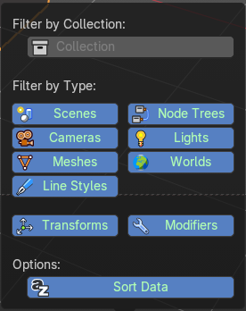
The show hide elements allows you to filter out the general elements. The Filters panel allows you to filter out further elements.

Filter by Collection
Just display the content from the chosen collection in the list of elements.

Filter by Type
In this section you can choose what type of animation data should be displayed. The names should be self explaining.

Options

Sort Data Blocks
Alphabetically sort the data in the list of elements.

Proportional Editing

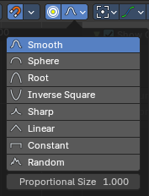
Enable proportional editing
Proportional editing allows you for example to scale two keyframes and influence the not selected neighbor keyframes in a proportional way. Or the proportional editing of fcurve points.

Proportional Editing Falloff
The drop down menu to choose the proportional editing falloff method. It is just available when the proportional tool is active.

Falloff Type
The falloff method

Proportional Size
Display size of the proportional editing circle.

Pivot Point
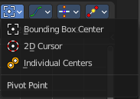
The pivot point defines the center of manipulations.

Bounding Box Center
Transformation happens around the bounding box center.

2D Cursor
Transformation happens around the timeline cursor.

Individual Centers
Transformation happens around the individual centers of the selected elements.

Easing Mode

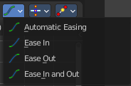
Easing Mode
The easing methods in the interpolation mode menu are for the easing shape. This menu allows you to choose an easing method.

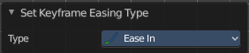
Last Operator Set Keyframe Easing Type

Type
Set the easing type.

Keyframe Handle Type
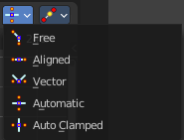
Set the handle type for the currently selected keyframes.
This is a feature for the Graph editor, where each curve point has its own handler with which you can influence the curve behavior. But the handler type also influences how the animation curve acts at the chosen keyframes. So it has its use in the dope sheet editor too.
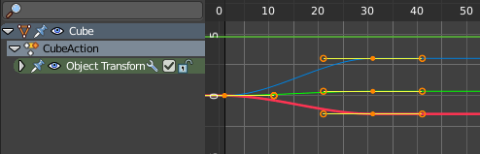

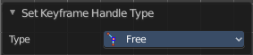
Last Operator Set Keyframe Handle Type

Type
Set the handle type for the currently selected curve point.

Keyframe Interpolation
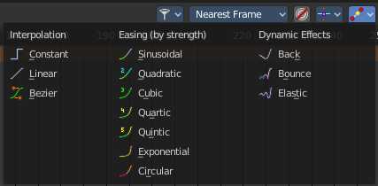
The keyframe interpolation mode defines how the curve acts from keyframe to keyframe. You can have a linear curve between two keyframes instead of a bent one for example.
The easing methods here in the interpolation mode menu are for the easing shape. There is also an easing menu where you can choose a easing method.

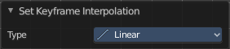
Last Operator Set Keyframe Interpolation

Type
Set the interpolation mode.

Options
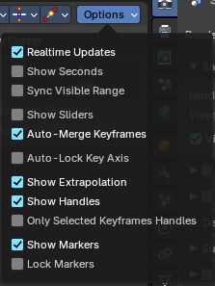

Real-time Updates
When transforming keyframes then this transformation is also immediately visible in other editors.

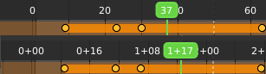
Show Seconds
Show the timing in the timeline area in seconds instead of frames.

Sync visible range
Synchronize the visible timeline range with other visible time based editors. When you zoom in or out in the one editor, then it zooms in or out in the other editor too. Each editor to sync needs to have Sync Visible Range ticked.

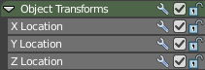
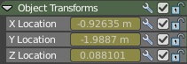
Show Sliders
Shows the value sliders for f-curve channels in the channel list.

AutoMerge Keyframes
Automatically merge nearby keyframes.

Auto Lock Key Axis
Automatically locks the movement fo keyframes to the dominant axis.

Show Extrapolation
Shows the curves after the last keyframe.

Show Handles
Show the handles at the keyframes.

Only Selected Keyframes Handles
Just show the handles of the keyframes from the selected curves.

Show Markers
Display the markers row at the bottom of the view.

Lock Markers
Make the markers uneditable.

